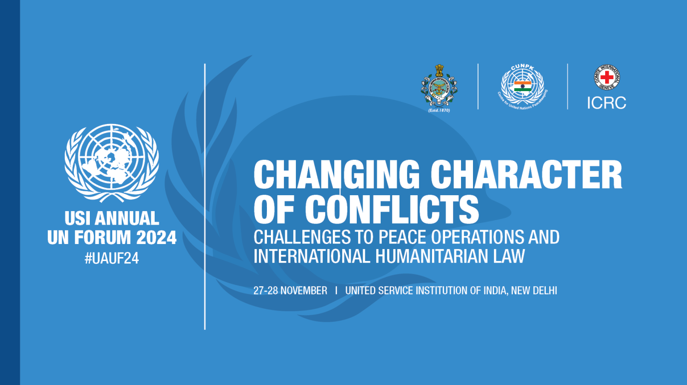

**CONCEPT NOTE**

**General**

The endeavour for global peace at the end of the Cold War, has largely given way to the current rise in vicious intra-state conflicts. While the world was grappling with the challenges of unresolved intra-state conflicts mostly in the African region, addition of the Ukraine and the Gaza wars have added new dimension to global violence and human suffering. As the UN Security Council remains deadlocked in political polarisation, conflicts have expanded in both scope and intensity.

The ongoing conflicts have highlighted disturbing trends of deliberate targeting of civilian population and indiscriminate bombing of civilian social support facilities, leading to large scale deaths and forced displacement resulting in an unprecedented humanitarian crisis. The operational techniques being applied, in ongoing conflicts, defy agreed protocols of the International Humanitarian Law (IHL) with minimal accountability.

Conflict has remained a constant feature of Social Darwinism exhibited in state behaviour. However, the traditional drivers have been over ridden by emerging disruptive technologies. Apart from cyber, AI driven advanced and autonomous weapon systems have changed the face of the battlespace. The conflicts now involve multi-domains, politics, diplomacy, technology, economy, information and cognition. The lines between classic war and peace are blurred with multitude of State and Non-State actors at play in a grey zone environment. Understanding and addressing these challenges requires a multi-dimensional and multi-disciplinary approach, as well as reforms in laws of war, governance architectures and International Institutions. How to foster cooperation in a contested World-Order is the biggest challenges. Some of the specific issues that merit reflection are laid out in the succeeding paragraphs.

**Protection of Civilians (PoC) and IHL**

IHL, also known as the law of armed conflict, regulates the behaviour of parties in armed conflicts to limit the effects of the conflict and protect those not or no longer taking part in hostilities[1]. Opinions on the interpretation of IHL vary due to the complexity of conflicts involving state and non-state actors, including Private Military Contractors (PMCs)[2]. In this context, PoC requires a comprehensive approach including interpretation and application of IHL but also ensuring accountability for violations of IHL.

**Accountability of Crime Committed Against Peacekeepers**

Accountability for the crimes committed against peacekeepers has emerged as a critical aspect of ensuring the safety and security of personnel deployed in UNPOs. From 2010 to 2023 (13 years), UNPO forces suffered 1631 fatal casualties as against 2683 from 1948 to 2009 (61 years). The host government has a particularly important role in investigating, prosecuting, and punishing those responsible for these crimes. However, if the host government is unwilling or unable to act, international mechanisms must be invoked.

**Climate Change and Environmental Driven Conflicts**

Climate change is transforming and redefining the global security and development landscape as well as both inter and intra-state conflicts[3]. Conflicts over land, food, and water are increasingly linked to environmental degradation, droughts, and natural disasters. Climate change is also aggravating vulnerabilities like poverty and inequality, and fuelling grievances to increase the risk of insecurity.[4] Climate change can thus limit the scope for keeping, making and building peace. Conflicts in the Sahel, where desertification and resource scarcity fuelled armed groups and ethnic violence, are an apt example. The relationships between climate change, peace and security are multifaceted, and responding to the engendered risks requires comprehensive responses from the multilateral international organisations.

**Women in Peace Operations**

Women play a crucial role in contributing to peace and security in conflict zones and are today an essential part of peacekeeping forces. Besides, women peacekeepers possess many unique skills, thus playing a positive role in making the peace process more inclusive and potentially reducing crimes against women[5]. The representation of women in peacekeeping has been low so far. The UN however has been gradually increasing the participation of women peacekeepers in forces as well as police over a period. With an overall goal of 25%, the UN had 19% military experts and staff officers, and 9% troops deployed in the field by June 2023.[6] These targets are 24% and 11% respectively by the end 2024[7].

**What is this event looking for?**

The discussion, spread over two days, seeks to address the evolving challenges of contemporary conflicts and explore innovative strategies to enhance global peace and uphold the principles of IHL

* **Changing Character of Conflicts.** Deliberations to analyse facets of evolving conflicts, and correlation with aspects of UN peacekeeping and application of IHL would remain relevant and effective in the mid-terms, thus must remain a priority.
* **Challenges to Peace Operations and International Humanitarian Law[8].** Discuss existing challenges and enhance participants' comprehension and create awareness of when and how IHL principles become applicable and relevant in contexts where UNPOs operate. Addressing these challenges requires a multi-dimensional approach.
* **Protection of Civilians and Peacekeepers.** Discuss challenges and threats to civilians, the peacekeepers and other UN components in the field, as well as legal and practical measures to ensure accountability for attempts on peacekeeper’s security and safety.
* **Climate Change and UN Peace Operations.** Discuss alarming effects of climate change on societies and ecosystems, and correlate them with growing evidence of its impacts on peace and conflict, with particular attention to fight over scarce resources in vulnerable regions.
* **Women in UN Peace Operations.** Discuss the contributions of women in the entire spectrum of peace operations, as well as the challenges. Deliberate on the institutional measures being put in place by the UN to enhance women participation. But the UN and its member countries have much to overcome to harness the potential and irreplaceable advantages, the female peacekeepers can bring in crucial missions around the world[9].
* **Future Roles and Models of the UN Peace Operations.** Enabling peacekeepers and UN components to be able to discern threats to the PoC mandate, analysis, and effective response generation with the help of emerging technologies.
* **Knowledge Sharing**: Share the experience of the practitioners as well as academicians and subject matter experts related to IHL and peacekeeping to encourage a multidisciplinary approach to addressing contemporary challenges and possibly provide input to the New Agenda for Peace.

**Conclusion**

The changing nature of conflict demands a flexible and adaptive approach from UNPOs. These missions must be equipped to address the multidimensional challenges of contemporary conflicts, focusing not only on the cessation of hostilities but also on long-term peacebuilding and development efforts. The approach must recognise the complex and interconnected nature of contemporary security challenges, legally acceptable humanitarian laws and measures to implement POC for promotion of sustainable peace.

1. Conceptualizing IHL: Denial of Quarter written by Sindija Beta and Dr. Greg Noone - https://www.publicinternationallawandpolicygroup.org/pilpg-ukraine-legal-blog; Other opinions and analysis by Public International Law & Policy Group (PILPG) - <https://ccl.org.ua/en/positions/conceptualizing-ihl-denial-of-quarter/>;

   Humar Rights Sit-Rep by the OHCHR - <https://www.ohchr.org/sites/default/files/documents/countries/ukraine/2023/23-03-24-Ukraine-35th-periodic-report-ENG.pdf>
2. Private Military Contractors (PMCs): <https://www.icrc.org/en/download/file/135841/montreux_document_en.pdf>;
3. https://www.nupi.no/en/news/climate-peace-and-security-research-paper-insights-on-climate-peace-and-security
4. Mobjörk, M., Krampe, F. and Tarif, K., ‘Pathways of climate insecurity: Guidance for policymakers’, SIPRI Policy Brief, Nov. 2020.
5. https://theglobalobservatory.org/2023/09/wps-in-the-new-agenda-for-peace-seeing-patriarchy-but-missing-innovation/
6. UN Peacekeeping – Gender (2024). https://peacekeeping.un.org/en/gender
7. Ibid.
8. Oberleitner, Gerd. “Human Security: A Challenge to International Law?” Global Governance 11, no. 2 (2005): 185–203. http://www.jstor.org/stable/27800564.
9. Bridges, D (March, 2020). Policy Forum. https://www.policyforum.net/barriers-for-women-in-peacekeeping/